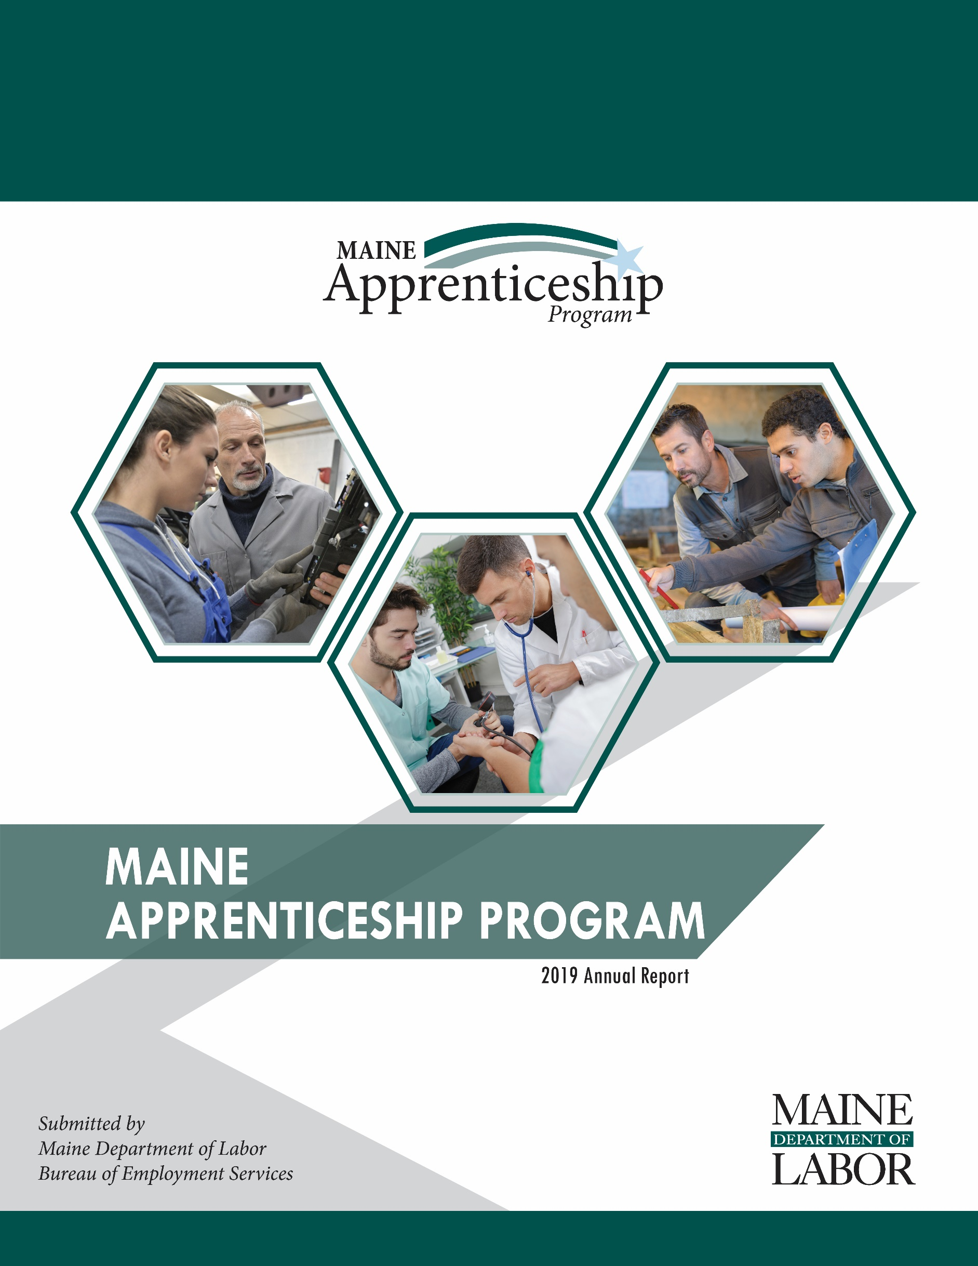

Maine Apprenticeship Program 2019 Annual Report
For the Period January 1, 2019 – December 31, 2019

Prepared for:
Governor Janet T. Mills
The Joint Standing Committee on Labor and Housing
The Joint Standing Committee on Education and Cultural Affairs

Submitted by:
Maine Department of Labor
Laura Fortman, Commissioner

The Maine Department of Labor provides equal opportunity in employment and programs.
Auxiliary aids and services are available to individuals with disabilities upon request.
Tel: (207) 623-7969 TTY users call Maine Relay 711 Fax: (207) 287-5292

2019 Apprenticeship Program Overview
The success of Maine’s economy is tied directly to the skill of our workforce and the creativity and innovation of our employers. Registered Apprenticeships are a vital part of Maine’s economy – they provide career pathways to high-quality jobs that allow apprentices to earn while they learn. Employers hone their future workforce by developing programs in which workers are performing required duties while learning skills needed for higher-level performance.
In Maine, these registered apprenticeships are part of the Maine Apprenticeship Program (MAP), which has been in place since 1941. The MAP is governed by Maine Statute Title 26 Chapter 37 § 3202 and Title 29 Parts 29 and 30 of the United States Code of Federal Regulations. Registered apprenticeships require at least 2,000 hours of on-the-job training and a minimum of 144 hours formal coursework for each year of the apprenticeship. MAP continues to innovate and adapt to meet employers’ needs for skilled labor and workers’ needs for good wages with a clearly defined pathway to career advancement.

The MAP has seen a dramatic increase in the number of sponsors and apprentices. Apprenticeship sponsors increased from 96 to 114 in 2019, which resulted in a 44 percent increase in the number of apprentices served (from 767 to 1,104). As shown in the graph, the construction sector contained the largest percentage of apprentices in Maine at 41 percent. This was followed by healthcare and professional services apprentices, each with 21 percent of Maine apprentices. Electrical apprentices, found in multiple sectors, comprised 24 percent of all apprentices.

Business and Training Engagement
Historically low unemployment combined with the aging workforce in Maine means that employers struggle to find the skilled workforce they require. Registered apprenticeship programs help them address their ongoing workforce training and retention needs. In addition to the 114 currently registered sponsors, there are 77 potential new sponsors in the pipeline. Eight of 77 potential sponsors are entering the final stages of the registration process.
During calendar year 2019, MAP staff registered 21 new sponsors of apprenticeship including the Washington County and the Southern Maine Community Colleges. The community college sponsors act as apprenticeship intermediaries for businesses in Maine. In their role as intermediaries the community colleges provide the classroom training and administer the program on behalf of the businesses. The businesses are critical to the success of quality apprenticeship training programs. They employ the apprentices and provide mentoring and structured on-the-job learning for the apprentices.

In September of 2019, the Maine Department of Corrections (DOC) joined the state Office of Information Technology as the second Maine state agency to become a registered sponsor of apprenticeship. DOC has engaged with the apprenticeship program to help resolve the ongoing challenge of recruiting and retaining corrections officers. To date, six corrections officers are participating in the DOC apprenticeship program.

2019 Program Highlights
- Maine realized a 166 percent increase in the number of registered apprentices between 2017 and 2019. In 2019, 2,813 apprentices were actively working on industry-recognized skill certifications, as compared to 1,056 in 2017.
- A three-year, $752,800 federal Apprenticeship Expansion Grant was received in July of 2019. The funding includes $245,500 to be used to offset the cost of apprentice classroom training during the grant period and supports one and a half positions to support the Maine Apprenticeship Program.
- Apprentices who completed their programs during 2019 attained an average wage increase of 41 percent.
- The estimated gross hourly wages paid by employers to Maine apprentices in 2019 was $92.5 million.
- Veterans make up 10 percent of Maine’s total populations while 16 percent of registered state’s registered apprentices.
- 195 women (seven percent of all apprentices) pursued training non-traditional occupations (NTO’s) such as machinist, non-destructive tester, pipefitter, electrician, shipfitter and welder among other occupations traditionally held by men.

Benefits of Apprenticeship
For Apprentices:
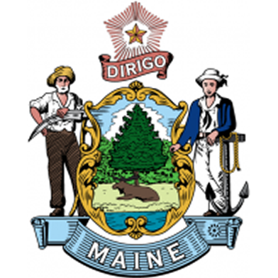
- Increased skills
- Paycheck while in training
- Higher wages
- Mentor support
- Job security
- Safer workplace
- Nationally recognized, portable credential
For Employers:
- Improved recruiting
- More diverse workforce
- Reduced turnover costs
- Higher productivity and fewer accidents
- Connection to training funds
- Apprenticeship program can be customized to meet employer needs
- Formalized approach that enhances existing business practices
- Average return on investment of $1.47 for every $1 invested
For Maine:
- Strengthens state’s economy by developing highly trained and educated workers
- Driven by employer demand and eliminates mismatch between skills taught and employers need
- Provides a customized, long-term solution to filling business workforce gaps as workers retire
- Allows combination with multiple workforce development and other funding streams
- Encourages secondary, post-secondary and workforce development system to work together with business to understand and better serve Maine’s workforce development needs

2019 Apprenticeship Participant Demographics
TOTAL SERVED | MALE | FEMALE | FEMALE-NTO | MINORITY | VETERANS
2,813 | 2,356 | 457 | 195 | 119 | 455

2019 In Numbers
Total taxpayer (State and Federal) dollars spent | $661,967
Average annual gross wages of apprentices | $38,626
Total served (new/active/completed/cancelled) | 2,813
Total new apprentices registered | 927
Total apprentices completing programs | 249
Total apprentices cancelled prior to completion | 380
Average age of apprentices at the start of their apprenticeship | 32 years old
Age range of apprentices registered in 2019 | 17 to 75 years old
Average starting hourly wage rate of all new apprentices in 2019 | $17.08
Average ending hourly wage rate at successful completion in 2019 | $23.76

MAP Funding
The Maine Apprenticeship Program has historically been 100% funded by state General Fund dollars. The General Fund appropriation traditionally supports three staff members and provides $200,000 for training reimbursements. However, this past year Maine also received a three-year Apprenticeship Expansion Grant totaling just over $750,000 from the United States Department of Labor. The grant funds were awarded to support the development of new programs, to provide oversight of existing Maine apprenticeship programs, and to increase staff capacity for expansion of apprenticeship opportunities.

The increase in funding through the federal government helped Maine address the increased demand for apprenticeship development and support. However, even with the increase in funding, Maine was no longer able to continue reimbursing sponsors for the cost of classroom training at the traditional rate. Maine statute allows the Department to reimburse sponsors up to 50 percent of the cost of classroom training. In recent years, the reimbursement rate had been up to $1,200 per apprentice per year. Based on increases in the number of sponsors requesting reimbursement and the available funding, reimbursements were reduced in 2019 to up to $500 per apprentice.

Maine Apprenticeship Council
The Maine Apprenticeship Council assists and advises the Department in the administration of the MAP. As required by Title 26 §3209 of Maine statute, the Council consists of twelve voting members who are appointed by the Governor. It also incldues four additional non-voting members appointed by the State Workforce Board; the Community College System; the Maine Department of Education; and, the Maine Department of Economic and Community Development.

2019 Members of the Apprenticeship Council:
- Jennifer McKenna, Chair, United Association Local 716
- Allan Shepard, IBEW Local 567 JATC
- Jennifer Boynton, MaineGeneral Medical Center
- Marion Sprague, Manufacturers Association of Maine
- Robin Wood, Reed & Reed, Inc.
- Dawn Croteau, Department of Health and Human Services, Office of Family Independence
- Tracey Cooley, PhD, Penobscot Job Corp Center
- Jonathan Mason, BIW and the State Workforce Board
- Tracie Travers, Jobs for Maine Graduates
- Denise Garland, Department of Economic & Community Development
- Lisa Larson, Eastern Maine Community College
- Dwight Littlefield, Department of Education, Career & Technical Education
            - Dan Coffey, Cianbro

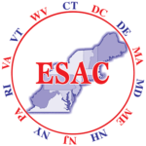
2019 Host of the Eastern Seaboard Apprenticeship Conference
The Maine Apprenticeship Program hosted the 75th convening of the Eastern Seaboard Apprenticeship Conference (ESAC) in Portland in May 2019. The ESAC conference is the oldest apprenticeship conference in the United States. ESAC promotes registered apprenticeship programs and includes representatives from labor, management, government, educational facilities, as well as small and large businesses. The conference provides a forum for business and industry, contractors, educators, labor organizations and apprenticeship programs to hear the latest federal and state regulations and policies governing apprenticeship and share information about new apprenticeship practices.
Jennifer McKenna, Chair of the Maine Apprenticeship Council, took the lead in organizing the event in collaboration with the ESAC leadership team. The theme was “Apprenticeship: Your Maine Investment.” Department of Labor Commissioner Laura Fortman was the keynote speaker. Topics discussed at the 2019 conference included: diversity; connecting to workforce funding; supporting women, veterans and people with disabilities; best practices in pre-apprenticeship; college partnerships; and, Job Corps programs.

Active Apprenticeship Sponsors 2019
In 2019, apprenticeship programs operating in Maine included 115 separate entities as active sponsors of 2,893 apprentices in 175 sponsor customized occupational programs. Currently, five types of apprenticeship sponsors are operating in Maine: group joint, single employer, intermediary, state agencies and a federal facility.

- The bulk of MAP sponsors continue to be individual businesses (101), many businesses employ one apprentice while some larger employers (ex: Bath Iron Works, CIANBRO, IBEW 567 Portland Electric, MaineGeneral Medical Center and Casella Resource Solutions) served more than 100 apprentices each in 2019.
- The six joint programs registered in Maine are union-sponsored joint apprenticeship training committees that have multiple signatory businesses working with their apprentices.
- Intermediary sponsors (7) in Maine act as apprenticeship intermediaries for their sub-employers who have agreed to hire and train apprentices using the curriculum and on-the-job training outlines established by the sponsor. State/City/County Agency sponsors (7) include 2 city agencies, 2 state employee programs and 3 correctional facilities that offer apprenticeship programming for incarcerated individuals.
- As a federally operated facility, Portsmouth Naval Shipyard (PNSY), is required to register their apprentices directly with the U.S. Department of Labor. PSNY employed 1,708 Maine-based apprentices in 28 different trades in 2019. The PNSY apprentices do not register through MAP.
Sponsor Name | Type of Sponsor | City
New Sponsors
Allagash Brewing Company | Employer | Portland
American Security Alarm | Employer | Sanford
Cris Contractors | Employer | Fryeburg
DeBlois Electric, Inc. | Employer | Lewiston
Estes Oil & Propane | Employer | York
Family First Funeral Homes | Employer | Gardiner
Franklin Homestead Kitchen, Bar and Bakery | Employer | Farmington
Ideal Electric | Employer | Winslow
Kincer Funeral Home, DBA Funeral Alternatives | Employer | Richmond
Maine Department of Corrections | State Agency | Augusta
Maine Office of Information Technology | Employer | Augusta
Metz Culinary Management | Employer | Lewiston
Modula | Employer | Lewiston
Pine State Services | Employer | Westbrook
Revision Energy, Inc. | Employer | South Portland
RGM Enterprises D/B/A Spillers | Employer | Lewiston
S J Rollins | Employer | Brewer
Southern Maine Community College | Community College/University | Portland
T&D Wood Energy, LLC | Employer | Sanford
Washington County Community College | Community College/University | Calais
WordLab, LLC | Employer | Portland
Continuing Sponsors
Acadia Integrative Medicine | Employer | Mt. Desert
Advantage Funeral Services | Employer | Portland
Alfred Water District | City/County Agency | Alfred
Aroostook County Action Program | Employer | Presque Isle
Aroostook Medical Center | Employer | Presque Isle
Associated General Contractors of Maine, Inc. | Intermediary | Augusta
Autumn Green Funeral Home | Employer | Alfred
Basix Automation Integrators | Employer | Dover
Bath Iron Works | Employer | Bath
Black Funeral Home | Employer | Springvale
Blaiklock Carpentry, Inc. | Employer | Woolwich
Boston Ocular Prosthetics, Inc. | Employer | Jackson
Boyne Resorts | Employer | Newry
Bragdon-Kelly Funeral Home | Employer | Ellsworth
Bridgton Veterinary Hospital | Employer | Bridgton
Brookings-Smith Funeral Home | Employer | Bangor
Burpee, Carpenter & Hutchins Funeral Home | Employer | Rockland
Casco Bay Electric, LLC | Employer | Portland
Casella Resource Solutions | Employer | Saco
Central Maine Motors Auto Group | Employer | Waterville
Cianbro | Employer | Pittsfield
Clover Manor, Inc. | Employer | Auburn
Cote Funeral Home | Employer | Saco
C-Prime Valuation Group, LLC | Employer | Freeport
Dan and Scott's Funeral Services | Employer | Farmington
David E Desmond Funeral Services | Employer | Bath
Day's Jewelers | Employer | Waterville
Dennett-Craig & Pate Funeral Home | Employer | Saco
Eastern Fire Protection | Employer | Auburn
Everett J Prescott, Inc. | Employer | Gardiner
Fortin Group Funeral Home | Employer | Lewiston
Gallant Funeral Home | Employer | Waterville
Gorham Healthcare, Inc. | Employer | Gorham
Hairbuilders | Employer | North Vassalboro
Hall Funeral Homes | Employer | Waldoboro
Hobbs Funeral Home | Employer | South Portland
Hope Memorial Chapel | Employer | Biddeford
HospitalityMaine | Intermediary | Augusta
IBEW1253, Augusta Electrical JATC | Union/Labor | Fairfield
IBEW567, Portland Electrical JATC | Union/Labor | Lewiston
Integrity Composites, LLC | Employer | Biddeford
Interstate Electrical Services, Inc. | Employer | York
Johnson & Jordan Mechanical Contractors | Employer | Scarborough
Jones, Rich & Barnes Funeral Home | Employer | Portland
Jordan Custom Carpentry | Employer | Center Lovell
Ken L. Electric, Inc. | Employer | Agatha
Kennebec Valley Community Action Program | Employer | Waterville
Kiley and Foley Funeral Service | Employer | Brewer
Knowlton, Hewins, & Roberts Funeral Home | Employer | Augusta
LaJoie Funeral Home and Cremation Services, LLC | Employer | Madawaska
Lamson Funeral Home | Employer | Millinocket
Lawry Brothers Funeral Home | Employer | Fairfield
LincolnHealth | Employer | Boothbay Harbor
Lucas & Eaton Funeral Home | Employer | York
Maine Association of Plumbing, Heating, Cooling Contractors, Inc. | Business Association | Cumberland
Maine Correctional Industries | State Agency | Windham
Maine Department of Corrections | State Agency | Warren
Maine Energy Marketers Association | Business Association | Brunswick
Maine Machine Products Co. | Employer | South Paris
Maine Medical Center / Maine Medical Partners | Employer | South Portland
Maine Shared Services Alliance | Business Association | Waterville
MaineGeneral Health | Employer | Augusta
Mancini Electric, Inc. | Employer | Portland
Massachusetts and No. New England Laborers | Union/Labor | Hopkinton
McIntire-McCooey Funeral Home | Employer | South Berwick
Mid-Coast Energy Systems | Employer | Damariscotta
Midstate Machine | Employer | Winslow
Moody's Collision Centers | Employer | Gorham
Mountain View Correctional Facility | State Agency | Charleston
Nestle Waters North America | Employer | Poland Spring
Northern Light Health | Employer | Waterville
OHI | Employer | Hermon
Panolam Industries, Inc. | Employer | Auburn
Paradigm Window Solutions | Employer | Portland
Patten Tool and Engineering, Inc. | Employer | Kittery
Pen Bay Medical Center | Employer | Rockport
Penobscot Job Corps | Federal Agency | Bangor
Plumbers and Pipefitters UA Local 716 | Union/Labor | Augusta
Pratt & Whitney | Employer | North Berwick
RCBI Apprenticeship Works-Maine | Intermediary | Saco
Reed & Reed | Employer | Woolwich
Ricker Hill Farms, Inc. | Employer | Turner
Riposta Funeral Home | Employer | Belfast
Seabee Electric, Inc. | Employer | Scarborough
Sheet Metal Workers Local 17 | Union/Labor | Lewiston
Shorey Nichols Funeral Home | Employer | Pittsfield
Southern Kennebec Child Development Corp. | Employer | Farmingdale
St. Mary's Regional Medical Center | Employer | Lewiston
Strong Agency, Inc.t | Employer | Thomaston
Thos. Moser Cabinetmakers | Employer | Auburn
UA Local 716 Plumbers & Pipefitters Union - Office | Union/Labor | Augusta
Veilleux Funeral Home | Employer | Waterville
Winthrop Utilities District | City/County Agency | Winthrop

Looking Forward
Registered Apprenticeship has a long history in Maine and across the United States. In fact, apprenticeships are practiced around the world. A Maine delegation, including representatives from the Department of Labor and the Department of Economic and Community Development, were invited to Germany to study its apprenticeship program.
Germany’s youth apprenticeship program is a particularly interesting model. A total of 19.8 percent of all companies there sponsor apprentices, and 53 percent of students exiting high school entered an apprenticeship program in 2017. By comparison, less than one percent of Maine employers use apprenticeship as a vehicle to train their workforce. The 2018 Education Indicators for Maine report stated the following: 87 percent of Maine high school seniors graduated in 2017; 63 percent of high school graduates enrolled in college; and, of those going to college, 84 percent returned for a second year and only 56 percent earned a two- or four-year degree in 2017. Overall, 44 percent of Mainers hold a postsecondary credential of value. Maine needs to develop more effective defined career pathways for the 56 percent of Mainers who do not earn a credential of value, and registered apprenticeships can play an important role.
The State’s economic development plan calls for increasing the knowledge, skills and abilities of Maine people. A vital piece of this is increasing the number of youth who continue their learning beyond high school graduation. Making career exploration available to youth from kindergarten up through their first year after high school graduation is a priority. The economic plan also calls for paid internships for youth to connect them to Maine’s workforce. Registered apprenticeships can play an important role in fulfilling this goal.
In 2020, the Department will collaborate with Career and Technical Education (CTE) High School programs, business and workforce partners to expand MAP programs to encompass high-quality youth apprenticeship programs. Youth apprenticeship programs provide a continuum of experiences beginning in middle school or even earlier with career exploration, job shadowing, work-based learning and relevant classroom training to prepare youth for entry into paid apprenticeship opportunities that begin as early as the age of 16. Ideally, youth apprentices earn credit toward high school graduation and college while earning a paycheck. Kentucky, North Carolina, Colorado and Maryland already have established youth apprenticeship programs
that align education and work-based learning strategies to meet employers’ needs for a highly skilled workforce. We will continue our investigation of these programs and determine how they can be implemented in Maine.

The current strategy to register intermediary sponsors of apprenticeship including associations, chambers of commerce and community college systems will continue in 2020. Registering intermediary sponsors of apprenticeship will increase the likelihood of small companies engaging with apprenticeship programing and help to leverage funding. The MAP program will continue to work closely with the Maine Community College System, Workforce Innovation and Opportunity Act programs, and other available programs to co-enroll apprentices providing affordable training and access to necessary support services.
Unlike many workforce development programs, apprenticeship does not provide any funding to offset the costs of necessary support services for registered apprentices. The Competitive Skills Scholarship Program (CSSP), another state-administered workforce development program, provides necessary support services to income eligible trainees. During 2019, a total of 18 apprentices were co-enrolled in CSSP. Co-enrollment in CSSP provided the eligible apprentices with support services such as transportation to and from classroom-based training, childcare and required books, tools and uniforms required for successful participation in their apprenticeship training program.
Unemployment rates remain historically low and the demand for the development of new apprenticeship programs continues to increase at a rapid pace. Now is an important opportunity to reflect upon Maine’s current apprenticeship program and consider any changes that may be advisable. The Department will continue its review of policies and practices in order to identify what changes, if any, are needed to meet the demands of workers and sponsors. In 2020, as mandated by statute, MAP will develop a two-year strategic plan for the program that will align with both the Maine Economic Development Strategy 2020 - 2029, and the WIOA State Workforce Plan scheduled to be finalized in the spring of 2020.

Success Stories
Jacob, Vocational Rehabilitation Project
Heavy Construction Carpenter Apprentice, Employed by Reed & Reed, Inc.,
Sponsor: Associated General Contractors


Jacob is a twenty-one-year-old graduate of Mt. Ararat High School in Topsham, Maine, who also completed a certificate program at SMCC in construction technology. He is primarily a “hands-on” learner, evidenced by reports that he has strengths involving spatial orientation, visual memory, and visual motor skills. Jacob chose to pursue the construction trades where concrete thinking and problem solving are an asset.
Barriers to employment, including non-verbal difficulties that limit expressive communication, social detachment and difficulty following oral directions, made it hard for Jacob to keep a job. He also struggles with assessing others’ social perspectives and needs, and had difficulty fitting in with his coworkers. Jacob was working with the Department of Labor Bureau of Rehabilitation Services (BRS) when a program to integrate apprenticeship training as a pathway to success for BRS clients was launched.
One of the features of the apprenticeship program is a written “schedule of work” that identifies the tasks the apprentice must learn under the guidance of a qualified mentor. Having access to these supports helped Jacob navigate the hiring and onboarding process while learning the tasks and demands of a new job. Given the way he learns and interacts socially, the one-on-one approach and structured on-the-job learning greatly benefited Jacob. It allowed him to get to know people, understand the expectations of his coworkers, and to participate as an inclusive member of a team while learning job skills under the guidance of a mentor and advocate.
Reed & Reed, Inc. is one of northern New England’s largest and most versatile general contractors and a sub-sponsor of apprenticeship under the umbrella of the Associated General Contractors of Maine sponsorship. Jacob is now successfully employed by Reed and Reed as a heavy construction carpenter apprentice. He reports he likes his job and thinks he is doing well. Reed & Reed management agrees with that assessment.
BRS counselors helped Jacob identify his barriers to successful employment. Becoming an apprentice put Jacob in the right environment where he can master his work skills while learning to navigate the workplace. Reed & Reed has made an investment in their workforce that will bring benefits to many.

Sarah E. Lilly, Lisbon, Maine
Bath Iron Works, Outside Machinist Apprentice
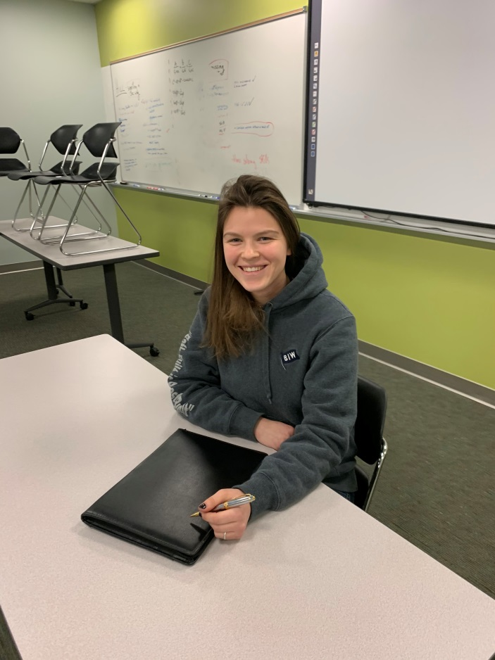
Sarah writes: In May of 2019 I was hired as an entry-level Outside Machinist, but after just a few days on the job I had my eye on BIW’s Apprenticeship Program. I heard about the apprentice program through word of mouth and before I knew it, I was clicking on the Apprentice Requisition on the BIW Career page. I’ve only been an apprentice for a short time, but it’s clearly opened a new and promising chapter in my life.
I recently earned a college degree in education while working as a commercial fisherman in Alaska, yet it wasn’t until I got married and moved permanently to Maine that I saw the immense opportunity provided by apprenticeship. Being in the Apprenticeship Program has made me realize how work and educational come together; it makes sense and has purpose.
I was most attracted to the apprenticeship program because I will earn an associate degree through a well-respected institution, Maine Maritime Academy, in a field applicable to my daily job function - and it’s totally funded by the company. Further, the job stability and an opportunity for longevity in the company was vital in my decision to pursue a career here. I am newly married, starting a family and want a stable career.
BIW is fully committed to creating a successful career pathway for each apprentice. It’s not simply earning a degree; it’s an amazing work experience, too. Most attractive to me is the long-term vision of the apprenticeship program. I am afforded mobility and the skill sets essential for growth in the company. I see myself striving and growing way beyond the expectations I had before entering the program. Ultimately my goal is to be in a position where I can serve in a vital and constructive role in the company that allows me to participate in overall decision making and be a resource for others as they learn and grow. I expect to graduate 2023 and am so excited to see how my career unfolds.

Published by the Maine Department of Labor
March 2020

Canadian Apprenticeship Forum retrieved on 1/13/2020; https://caf-fca.org/apprenticeship-101/hiring-an-apprentice/
Apprenticeship System in Germany retrieved February 11, 2020; https://www.apprenticeship-toolbox.eu/germany/apprenticeship-system-in-germany
Education Indicators for Maine 2018, Educate Maine, page 22
Linked Learning. (n.d.). About the Linked Learning Approach. Retrieved February 11, 2020 from https://www.linkedlearning.org/about/linked-learning-approach

